**DESIGN AND IMPLEMENTATION OF SIWES ELECTRONIC LOGBOOK MANAGEMENT SYSTEM**

VOCATIONAL SKILLS & ENTERPRENEURSHIP STUDY CENTER (V.S.E.S.C)

THE POLYTECHNIC IBADAN

**PREPARED BY:**

**ADEDAPO ABIODUN JOSEPH**

**2019235020021**

**A PROJECT SUBMITTED TO THE DEPARTMENT OF**

**COMPUTER STUDIES, FACULTY OF SCIENCE, THE POLYTECHNIC IBADAN**

**IN PARTIAL FULFILMENT FOR THE REQUIREMENT FOR THE AWARD OF NATIONAL DIPLOMA IN COMPUTER SCIENCE**

**MAY 2022**

# CERTIFICATION

This is to certify that the project was carried out by **ADEDAPO ABIODUN JOSEPH** with matriculation number **2019235020021** under the thorough and constructive supervision of **DR. MRS ADELODUN** of the department of **COMPUTER SCIENCE, THE POLYTECHNIC IBADAN.**

……………………………….. ………………..…………

**DR. MRS. ADELODUN F.O. DATE**

Project Supervisor

……………………………….. ………………..…………

**MR. FADIORA B. O**  **DATE**

Head of Department

# DEDICATION

I dedicate this project to God Almighty my creator, my strong pillar, my source of inspiration, wisdom, knowledge and understanding for seeing me throughout my stay in the polytechnic Ibadan. He has been the source of my strength throughout this program and on His wings only have I soared.

# 

# ACKNOWLEDGEMENT

This research paper is made though the help of many people who include parents, family and friends. Especially, please allow me to acknowledge with gratitude the following significant advisors and contributions. First and foremost, I really appreciate my parents in person of **MR & MRS ADEDAPO** for their support and encouragement.

My special gratitude to my supervisor **DR. MRS. ADELODUN** and head of the department, **MR FADIORA B.O** for their guidance, immeasurable correction and good supervision of this project. Also, my gratitude goes to my qualified lecturers: **MR EGBEDOKUN G.G.O, MRS IBITOWA F.O, MRS ONI, MRS ORIOKE O.O, MR OMOTOSHO F.S, MR AGBOLADE S.J, MRS. AJIBOYE, MR ADEGBOLA A.A, MRS GANIYU, MRS ADELODUN F.O.**

# ABSTRACT

This project work investigates an electronic logbook for Student’s Industrial Work Experience Scheme was designed to minimize the problems associated with the paper logbook such as susceptibility to manipulation or forgery, wearing, and storage problem and retrieval problems. An industrial supervisor is also expected to monitor the student’s weekly progress of work and append his signature for works actually done by the student.

To ensure that the aim of EED is achieved, a school-based supervisor is also expected to monitor the student's progress by visiting his place of primary assignment at regular intervals, and by the end of the exercise, a report is usually sent to the ITF office for verification and necessary documentation and payment of those who participated in the exercise. Each student uses a logbook to keep record of his/her experiences.

Traditionally, a logbook is a record of an event or events such as ship’s navigation, air flight, inventions, teachers’ events in the classroom etc. logbooks have been in existence since the invention of ships and the need for navigation came into existence. Today’s logbooks have diverse uses since all aspects of human endeavor need a form of reference or storage media.

However, with the advent of ICT and the internet the ways of doing things have changed.  An electronic logbook is a computer-based software for recording (logging) states, events or simply conditions used for complex machines like aircraft, nuclear plants, particle accelerators, various areas on board ships replacing paper-based logbooks etc.  An electronic alternative to record key navigation, engine watch, port calls and other operational activities on board vessels of all sizes.

.

TABLE OF CONTENTS

TITLE PAGE……………………………………………………………………………..……….i

CERTIFICATION ii

DEDICATION iii

ACKNOWLEDGEMENT iv

ABSTRACT v

TABLES OF CONTENT…………………………………………………………………………vi

CHAPTER ONE 1

1.0 INTRODUCTION………………………………………………………………………1

1.1 INTRODUCTION………………………………………………………………………1

1.2 STATEMENT OF PROBLEM 4

1.3 JUSTIFICATION OF STUDY 4

1.4 AIM AND OBJECTIVES 4

1.5 SCOPE OF STUDY 5

1.6 METHODOLOGY 5

1.7 DEFINITION OF TERMS 5

CHAPTER 2 7

2.0 LITERATURE REVIEW 7

2.1 BACKGROUND OF STUDY 7

2.2 RELATED WORKS 12

2.3 ELECTRONIC LOGBOOK 16

2.4 ADVANTAGES OF ELECTRONIC LOGBOOK 17

2.5. CURRENT METHOD IN USE 19

2.6. APPROACH TO BE USED IN THIS STUDY 19

CHAPTER THREE 20

3.0 SYSTEM INVESTIGATION AND ANALYSIS 20

3.1 BACKGROUND INFORMATION ON CASE STUDY 20

3.2 OPERATION OF THE EXISTING SYSTEM 21

3.3 ANALYSIS OF FINDINGS 21

3.4 PROBLEMS IDENTIFIED FROM ANALYSIS 22

3.5 SUGGESTED SOLUTIONS TO PROBLEM IDENTIFIED 22

CHAPTER FOUR 23

4.0 SYSTEM DESIGN 23

4.1 OUTPUT DESIGN 23

4.2 INPUT DESIGN 25

4.3 PROCESS DESIGN 27

4.4 STORAGE DESIGN 28

4.5 DESIGN SUMMARY 30

CHAPTER FIVE 32

5.0 SYSTEM DEVELOPMENT AND IMPLEMENTATION 32

5.1 PROGRAM DEVELOPMENT ACTIVITY 32

5.2 PROGRAM TESTING 32

5.3 SYSTEM IMPLEMENTATION 33

CHAPTER SIX 35

6.0 SYSTEM DOCUMENTATION 35

6.1 FUNCTION OF PROGRAM MODULES 35

6.2 USER MANUAL 35

CHAPTER SEVEN 37

7.0 SUMMARY, CONCLUSION AND RECOMMENDATION 37

7.1 SUMMARY 37

7.2 CONCLUSION 37

7.3 RECOMMENDATIONS 38

REFERENCES 39

APPENDIXES 43

APPENDIX A 43

SYSTEM FLOWCHART 43

APPENDIX B 45

SOURCE CODE 45

APPENDIX C 50

SAMPLE INPUT 50

APPENDIX D 52

SAMPLE OUTPUT 52

# CHAPTER ONE

**1.1 INTRODUCTION**

The Students Industrial Work Experience Scheme (SIWES) is a new Directorate under the Vice-Chancellor’s Office.  It was established on 20th April, 2012. The Students Industrial Work Experience Scheme (SIWES) is a skills training program designed to expose and prepare students of universities and other tertiary institutions for the Industrial Work situation they are likely to meet after graduation.  It is also a planned and structured program based on stated and specific career objectives which are geared towards developing the occupational competencies of participants (Mafe, 2009).  Consequently, the SIWES program is a compulsory graduation requirement for all Nigerian universities and polytechnics students offering certain courses. The Students Industrial Work Experience Scheme (SIWES), is the accepted training program, which is part of the approved Minimum Academic Standard in the various degree program for all Nigerian Universities.  The scheme is aimed at bridging the existing gap between theory and practice of Sciences, Agriculture, Medical Sciences (including Nursing), Engineering and Technology, Management, and Information and Communication Technology and other professional educational program in the Nigerian tertiary institutions.  It is aimed at exposing students to machines and equipment, professional work methods and ways of safeguarding the work areas and workers in industries, offices, laboratories, hospitals and other organizations.

Scientists and engineers traditionally kept paper logbooks of their experiments and inventions. The need for the logbook is cannot be over emphasized. Scientists need to keep a record of their doings in order to remember and report what has been done. The logbook also gives a means of retracing past experiments and verifying their accountability. Searching logbooks can also determine who the first was to make a new discovery or invention. In most parts of the world, the first to invent rule is used for patents and a properly kept logbook is crucial for proving an idea is yours. Student and professional bodies use logbook on regular intervals, Altini etal (2010).

In less than twenty years the habits of logbook use have changed radically. Even though some scientists still solely use old fashioned paper logbooks many large scientific collaborations are already using electronic logbooks, wave tracks (2010).

The students industrial work experience scheme (S.I.W.E.S) is an industrial training program for undergraduate students of Nigerian universities and other higher institutions. It is a six-month training scheme in which students are attached to industries that are relevant to their field of study. The Industrial Training Fund (ITF) is the body responsible for the coordination and funding of the program.

The Industrial Training Fund (ITF) was created in 1971 with the promulgation of decree 47 of 1971. ITF was charged with the responsibilities of manpower training and development in general, with the specific mandate to promote skills acquisition in Industry and Commerce. R. Akerejola (2004) noted that the Students’ Industrial Work Experience Scheme (SIWES) was created in 1974 by the ITF to bridge the identified gap between theory and practice in our tertiary institutions. Before the advent of the Students’ Industrial Work Experience Scheme (SIWES), students studying practical courses especially in science and technology were being set out with little or no practical knowledge of their various courses of study. The SIWES program is a compulsory graduation requirement for all Nigerian university students offering certain courses. In preparation for this program, such students are required to visit the departments in their various institutions in charge of it in order for the department to prepare them for their industrial training. They are also required to go in order to collect documents that they are to fill during the course of their industrial training. One of such documents is the Logbook. The logbook is a book that contains the daily activities done by the student during the course of industrial training. The student is required to fill the logbook daily and the student is also required to give it to the industry-based supervisor to sign and comment weekly and then at the end of the industrial program, the student is to submit it back to school. Each year, higher institutions spend a lot of money in order to print these logbooks, money that could be put into better use if the logbook application is put into place. The work of marking these logbooks by the lecturers is also made difficult, as for them to mark the logbooks they would have to wait until all students have finished their industrial training, be it 6 months or 3 months and this can be very cumbersome on the lecturers and would also take a lot of time. Supervisors in most cases have to travel down to wherever each student is doing his/her Industrial training in order to inspect and some of these distances could be quite far. In travelling, supervisors encounter a lot of stress and also expose themselves to unforetold risks. Due to this, supervisors tend to visit students just once leading to inadequate monitoring of students’ activities. When students resume after their Industrial Training, they submit their IT logbook in hardcopy which can be prone to theft and also destruction by natural disasters. The study aims at developing an electronic logbook in the form of a website that would serve as a better alternative to the paper logbook system that is currently being used in the higher institutions in Nigeria.

The basic objectives of Students’ Industrial Training Work Experience Scheme (S.I.W.E.S) embraces the following:

* To provide opportunities of applying their knowledge to real practice thereby making easier the college work.
* To enable students to practice theory been taught at school and provide access to the production equipment not available in the school.
* To provide skillful experience to all students in the school of technologies, polytechnics and universities.
* To inspire students about their careers
* To provide more man power to industries.

Every student is expected to keep a record of her experience for the duration of the training period and submit such records to her department on resumption for further studies. An industrial supervisor is also expected to monitor the student’s weekly progress of work and append his signature for works actually done by the student. To ensure that the aim of SIWES is achieved, a school-based supervisor is also expected to monitor the student’s progress by visiting his place of primary assignment at regular intervals, and by the end of the exercise, a report is usually sent to the ITF office for verification and necessary documentation and payment of those who participated in the exercise. Each student uses a logbook to keep record of his/her experiences.

Traditionally, a logbook is a record of an event or events such as ship’s navigation, air flight, inventions, teachers’ events in the classroom etc. logbooks have been in existence since the invention of ships and the need for navigation came into existence. Today’s logbooks have diverse uses since all aspects of human endeavor need a form of reference or storage media.

However, with the advent of ICT and the internet the ways of doing things have changed. An electronic logbook is a computer-based software for recording(logging) states, events or simply conditions used for complex machines like aircraft, nuclear plants, particle accelerators, various areas on board ships replacing paper-based logbooks etc. An electronic alternative to record key navigation, engine watch, port calls and other operational activities on board vessels of all sizes.

## 1.2 STATEMENT OF PROBLEM

The need for an electronic logbook for S.I.W.E.S cannot be over emphasized. For a student to gain the required knowledge from industrial training experiences, he/she must be well monitored to ensure that he/she does not just participate in the training scheme in fulfillment of its mandatory status, but also acquire relevant experiences. The lack of electronic logbook makes this nearly impossible since distance between interns and supervisors and the lack of access to good reference source hinders the actualization of the desired goals. The problems faced by the manual type logbook are resolved by the implementation of our electronic logbook system. It will bring an advanced means of recording events, monitoring students’ daily activities and progress in a much easier and efficient way. Due to the use of a database engines siwes supervisors would be able to print student’s logbooks and easily access/stores student’s data.

## 1.3 JUSTIFICATION OF STUDY

Implementation of Siwes Electronic Logbook system will replace conventional analog type, paper-based logbook board with digital logbook which would make supervision much easier. As has been stated in section 1.2, there are lots of problems with the traditional logbook that justify the quest for a better way of handling internship experience logbook. Perhaps the most outstanding of this reason is the bridging of the gap between supervisors and interns.

## 1.4 AIM AND OBJECTIVES

The Aim of the project is to design and implement an electronic logbook for Students’ Industrial Work Experience Scheme (S.I.W.E.S)

The objectives are as follows:

* To review and analyze the existing system
* To develop a software capable of logging students’ work entries in an electronic format.
* To bridge the gap between the students and supervisors during the course of the industrial training.
* To provide important links that are capable of enhancing the performance and knowledge of the Nigerian graduate.

## 1.5 SCOPE OF STUDY

This project work is majorly focused on providing an electronic logbook, limited to the Nd2 student in the department of computer science.

## 1.6 METHODOLOGY

In the development of any project, a very important requirement is the gathering of data for the project. It uses the following method to gather the necessary and required data for development.

Interview Method: This has to do with carrying out one to one interview with those involved, particularly the Lecturers and students so as to know their opinion as regard to the existing system.

Observation Method: This involves self-observation from the research to understand the current system and identify the short coming of the system in order to design the new system.

## 1.7 DEFINITION OF TERMS

### PHP:  PHP is an acronym for "PHP: Hypertext Preprocessor". PHP is a general-purpose scripting language especially suited to web development

### HTML: HTML stands for Hyper Text Markup Language · HTML is the standard markup language for creating Web pages

### DBMS: Stands for "Database Management System." In short, a DBMS is a database program. Technically speaking, it is a software system that uses a standard method of cataloging, retrieving, and running queries on data.

### Database: A database is an organized collection of data, generally stored and accessed electronically from a computer system. Where databases are more complex they are often developed using formal design and modeling techniques.

### Administrator: A person who monitor the students that as submitted their logbook

### User: is the person that enters the activities he/she did for that day.

### Logbook: A logbook is a record of important events in the management, operation, and navigation of a ship. It is essential to traditional navigation, and must be filled in at least daily. The term originally referred to a book for recording readings from the chip log that was used to estimate a ship's speed through the water.

### Electronic: Electronics is defined as devices run by electric power or the field of studying such items. An example of electronics are radios, computers, and televisions. ...(physics)The study and use of electrical devices that operate by controlling the flow of electrons or other electrically charged particles.

# CHAPTER 2

## LITERATURE REVIEW

## 2.1 BACKGROUND OF STUDY

Industrial training is a bridge from the classroom to the workplace. R. Akerejola (2004) defined industrial training as an opportunity to test skills, interests and career choices in real work situations while obtaining an edge on “inexperienced” job market competitors. The industrial training program has become a necessity for students to partake in order to complete their educational program, especially students of the Science, Engineering, and Technology disciplines. S. Osman et al, 2008 evaluated students in various areas which can be summarized into three main areas which are attitude, communication and work attitude before and after the industrial training program. The results showed that the average score of the students increased from 48% - 63% before the Industrial Training to 89% - 95% after the Industrial Training S. Osman et al., 2008. Over the years the industrial training has been very beneficial to students, J. A. Cannon (2009) noted that students see the industrial training as a means to land their first job, R. Hite  et al., (2010) found that students view internships as a valuable learning experience through which they receive an academic grade and also financial compensation. The advantages of Industrial Training include:

Industrial training provides a platform that renders practical knowledge of all they have been taught in school. Students are trained, tutored and mentored by trained and seasoned professionals. Industrial Training helps students to gain valuable work experience for some students this might be the first time of them in a working environment in the real world

In this current world where “who you know” matters a lot, industrial training provides a platform for students to network with professionals who are years ahead of them. A lot of companies use industrial training as a means to recruit new staff. Industrial Training thereby provides job opportunities for students once they graduate.

The Industrial Training Fund (ITF) was created in 1971 with the promulgation of decree 47 of 1971. ITF was charged with the responsibilities of manpower training and development in general, with the specific mandate to promote skills acquisition in Industry and Commerce. R. Akerejola (2004) noted that the Students’ Industrial Work Experience Scheme (SIWES) was created in 1974 by the ITF to bridge the identified gap between theory and practice in our tertiary institutions. Before the advent of the Students’ Industrial Work Experience Scheme (SIWES), students studying practical courses especially in science and technology were being set out with little or no practical knowledge of their various courses of study. The SIWES program is a compulsory graduation requirement for all Nigerian university students offering certain courses. In preparation for this program, such students are required to visit the departments in their various institutions in charge of it in order for the department to prepare them for their industrial training. They are also required to go in order to collect documents that they are to fill during the course of their industrial training. One of such documents is the Logbook. The logbook is a book that contains the daily activities done by the student during the course of industrial training. The student is required to fill the logbook daily and the student is also required to give it to the industry-based supervisor to sign and comment weekly and then at the end of the industrial program, the student is to submit it back to school. Each year, higher institutions spend a lot of money in order to print these logbooks, money that could be put into better use if the logbook application is put into place. The work of marking these logbooks by the lecturers is also made difficult, as for them to mark the logbooks they would have to wait until all students have finished their industrial training, be it 6 months or 3 months and this can be very cumbersome on the lecturers and would also take a lot of time. Supervisors in most cases have to travel down to wherever each student is doing his/her Industrial training in order to inspect and some of these distances could be quite far. In travelling, supervisors encounter a lot of stress and also expose themselves to unforetold risks. Due to this, supervisors tend to visit students just once leading to inadequate monitoring of students’ activities. When students resume after their Industrial Training, they submit their IT logbook in hardcopy which can be prone to theft and also destruction by natural disasters. The study aims at developing an electronic logbook in the form of a website that would serve as a better alternative to the paper logbook system that is currently being used in the higher institutions in Nigeria.

Many higher and further education institutions now run Virtual Learning Environments (VLEs), with tools for course management, assessment and group working. Although they have been widely adopted, VLEs are limited in their support for new methods of teaching and learning such as problem-based learning, informal teamworking, and personal learning management. Nowadays, most learners are no longer confined to a single institution throughout post-school education. The availability of part-time courses, work-based learning and other informal learning activities all contribute towards the attainment of an individual’s learning goals. It is expected that people well continue to acquire new skills throughout their lifetime and build a transferable portfolio of competences JISC (2005a).

Another trend in tertiary education is towards small group collaborative learning. Students are expected to acquire competences in collaborative working and project management through team projects and group-assessed coursework. In recent years these have typically been mediated by online discussion and coordination. Learners and tutors may use a variety of informal collaborative tools such as newsgroups, weblogs and instant messaging alongside the tools that are provided by the institutional VLE. This increases the number of logins required by the users as they move from one system to the next, presenting a major challenge to search and retrieve relevant learning materials. In addition, students may use a wide range of overlapping Personal Information Management (PIM) tools such as calendars, contact lists and email, running on computers and mobile phones. The information across these devices and applications needs to be consolidated into one place and directed towards support for learning

Corlett, D. & Sharples, M. (2004).

A third trend is the requirement on tertiary education to support students in maintaining learning portfolios and personal development plans, as aids to reflective learning and as transferable records of achievement. In science and engineering disciplines there is a long tradition of using paper-based logbooks to record and review learning activities. A problem with the paper-based logbook is that much learning activity is now carried out online, through email, web browsing and word processing. Currently, students have to add these online activities to the paper logs by printing out the documents or transcripts of email and pasting them into the logbook. Activities such as interactive software design and video production can only be included in the logbook as CDROMs or as references to online websites. New designs for virtual learning environments are reflecting these educational changes, adding tools for collaborative document production, student project management and multimedia presentation, as well as integration with content management, student administration, and examination. However, they are still designed around the structure of the curriculum, rather than the needs of the individual student. Even if the learning can be captured and presented online, this is a taxing process. Students must save and organise their online activities from a variety of sources including tasks carried out on the VLE, email correspondence, and material they may have designed in the form of documents, presentations, web pages, video, audio, and computer programs Corlett, D., (2005).

The continuous quest to bridge the gap between industrial work practices and the knowledge gained in institutions has remained the major driving force in supporting Internships. This as a result of the fact that students graduate with little or no working knowledge of the industry practices there by finding it difficult to cope once employed (Abdullahi, 2009). This is especially true for science and technical oriented courses. Therefore, the need to acquire the relevant experiences from industries before graduating from institutions becomes a necessity before graduating from institutions. Due to this fact in 1973, Nigeria government developed an internship program, Students’ Industrial Work Experience Scheme (SIWES) to be headed and managed by Industrial Training Find (ITF). ITF as a body was charged with such responsibility and with backing from the Nigerian constitution of Decree 47 of 1971 to judiciously utilize the funds that would from time to time be allocated to it for ensuring that students of tertiary institutions in Nigeria acquire good working experience before graduating (Adetiba et al., 2012). The result of such scheme was hopefully to train self-reliant Nigerian students who would bring the positive impact and change in the economic situation of the nation. In 1979 the Industrial Training Fund, withdrew from the managing the scheme due to problems of organizational logistics and the increased financial burden as a result of rapid expansion of SIWES (ITF, 2016). The scheme is a tripartite programme that incorporates the students, the institutions, and the industries. In Nigeria SIWES is financed by the federal government International Journal of Innovative Information Systems & Technology Research 8(3):1-13, July-Sept., 2020 © SEAHI PUBLICATIONS, 2020 www.seahipaj.org ISSN: 2467-8562 2 (through the ministry of commerce and industry) and managed by the Industrial Training Fund (ITF) aiming at making education more relevant and also to bridge the yearning gap between theory and practice of Engineering, Technology and other related disciplines in tertiary institutions in Nigeria. SIWES is a form of cooperative industrial internship programme among all its stake holders. Mafe (2009) stated that all stakeholders are involved in the operation of SIWES but that students are the key actors that are directly involved in its implementation, all other stakeholders have lesser role to play in the actual training process. Mafe (2010) citing Crag (1987) stated that, SIWES is generic because it cuts across more than 60 programmes in the universities, over 40 programmes in the polytechnics and about 10 programmes in the colleges of education. Students who participate in this training programme include those studying Library and Information Science, Engineering, Vocational, Technological and related courses in higher institution of learning. Other courses involved in SIWES include Agricultural science, Forestry, Industrial Chemistry, Microbiology, Geology and Mineral Science, Physics and Mineral Science, Plant and Environmental Biology, Computer Science, Tourism and Hospitality, Business Education, Industrial Engineering, Enterprise Creation and Management. The success of the scheme requires collaboration between ITF, Industries, and the Tertiary institutions of the country and the constitution provided for such. The extent of objective realization and acceptability of SIWES in Nigeria has been described in several researches that assess the impact and challenges of the scheme. Ukwueze, (2011) shows that the scheme has positive impact on students as they showed employability skills after participating in the SIWES; also Oyeniyi, (2012) shows that graduates demonstrated the significant impact of the scheme in terms of skills acquisition and utilization; research also shows that students, having participated in the scheme, show acceptability of the scheme and encourage continuous support of it by the relevant bodies and Government (Nse, 2012). However, the scheme is still faced with several challenges that inhibit the full realization of the objective of the scheme. Among many are challenges associated with proper supervision and coordination of the process, non-compliance by industries to accept such students (Nse, 2012); fuzzy job specification for the different courses, students’ interest in participating in a skill oriented projects, and inadequate supervision (Olabiyi and Okarfor, 2012); other challenges included finances, students’ placements, irregular academic calendars (Ojokulu et al., 2015). These and several other researches show that coordination and supervision has remained the biggest challenges towards the full realization of SIWES scheme in Nigeria. There are lots of problems with the traditional logbook that justify the quest for a better way of handling internship experience logbook. Perhaps the most outstanding of this reason is the bridging of the gap between supervisors and interns. The Nigerian academic curriculum has witnessed a lot of disruptions in recent times mostly because of massive industrial actions to drive home a demand. Only recently, the Nigerian universities, Polytechnics and Colleges of Education embarked on an over six month’s nationwide strike. The students who were undergoing IT training at that time will have to depend solely on their industry supervisor and instincts. With information technology and the gains associated with it, most nation of the world has successfully migrated from the paper method of keeping records. It is therefore a worthwhile venture to affirm the already introduced practice of modernity since we have much to learn/do if we are to be able to be able to rub shoulders with our counterparts elsewhere. Presently, an internship student needs to make their logbook in a physical paper which is only visible for him or herself view. Then after their internship program is done, they need to come back to their various institutions in order to submit the logbook to the lecturer for grade and graduation purpose. Therefore Supervisors have to wait till the end of the training scheme to assess the performance of the students. As a result of this problem, supervisors find it very difficult to monitor the progress of the student regularly. It is against this backdrop that this study, sort the way to bridge the gap between the student on IT and the supervisors.

## 2.2 RELATED WORKS

Related works include E. Adetiba et al., (2012) designed and developed a web-based SIWES management system for Covenant University. The system was developed to computerize the analogue activities carried out throughout the process of a student embarking on the SIWES program.

Also, The Abubakar Tafawa Balewa University (ATBU) Bauchi designed and developed a web-based SIWES portal for students involved or to be involved in the program. Students are given personal login details. All documents that would need to be filled by said students while on the program are available for download on the web portal except the logbook. A brief electronic copy of a SIWES orientation is also available to students.

Anthony T. OLAJIDE Dept. of Computer Science Kwara State Polytechnic Ilorin, Kwara State, Nigeria [Development of e-SIWES Portal: A Web based Platform for Student Industrial Work Experience Scheme (SIWES) Management](https://www.researchgate.net/publication/260256614_Development_of_e-SIWES_Portal_A_Web_based_Platform_for_Student_Industrial_Work_Experience_Scheme_SIWES_Management).

The Federal University of Technology Owerri created a SIWES form on a web page that was integrated into the default students’ portal. Students that are to embark on the program are required to login to their portal, to then click on SIWES and then clicking on SIWES form. There the student would then fill out a SIWES placement form before then printing out an acknowledgement slip FUTO, 05 June (2018). The limitation of these systems is that students are not able to fill their logbook online. This system can only be used to register students that are embarking on the SIWES program.

Cheff et al, cited in Sinnasamy and Nasir (N.D) posit that while it was sufficient in the past for library schools to teach students the rudiments of housekeeping library collections and training was basically in the area of cataloguing and classification; the expectations today is different. According to them, with the rapid advances in ICT, the field of Library and Information Science (LIS) has become specialized and technical in nature demanding that students’ training incorporates the elements of theory and practice. In essence, in the current environment, in addition to possessing traditional librarianship skills, LIS students are also expected to possess other general and personal skills required for transfer from one job to another (Orme, 2008). SIWES or industrial training as it is commonly called is seen as a viable avenue through which students can gain the much-needed competencies and skills (Ojokuku, Emeahara, Aboyade & Chris-Israel, 2015; Kuranaratne & Perera, 2015). This is because it offers them opportunity to experience on-the-job-training and real-life job experience while still in school (Ballinger & Lalwani, 2000). Also, through it, students are made more aware of the needs and expectations of the industry and so are able to prepare themselves for the world of work. In the same vein, Ojokuku, Emehara, Aboyade & ChrisIsrael (2015) posit that by actively participating in industrial training, students are able to appreciate work methods and gain experience in handling equipment and machinery which may be unavailable in their institutions. Furthermore, Karunaratne & Perera (2015) are of the view that industrial training provides students with significant benefits in career preparation and income and also strengthens their self-confidence and self-satisfaction in the lifelong learning process. Knouse, Tanner & Harris (1999) and Mihail (2006) add that students who have been through industrial training are more likely to find jobs more quickly than those who did not, given the competencies and skills they acquire and the contacts they make while in training. Be that as it may, students are not the only beneficiaries of industrial training as employers and the learning or parent institutions also stand to benefit (Mgaya &Mbekomize, 2014; Bukaliya, 2012). In their view, while students need an avenue to gain those competencies and skills that will bring them up to the level and expectation of employers, the employers on their part need competent graduates who are ready for immediate employment. The learning or parent institutions on the other hand, benefit through increased cooperation and rapport with the industry. A number of studies have identified some areas where students of LIS programmes need to enhance their competencies and skills. In Nigeria, Nwalo & Oyedum (2011) in their study evaluated the information literacy skills of undergraduate LIS students and found it to be generally poor. Similarly, Issah, Amusan, Olarongbe, Igwe, & Oguntayo (2015) assessed the information literacy competencies of undergraduate students of University of Ilorin, Kwara State Nigeria and found that majority had limited information literacy skills amidst limited exposure to information literacy programmes. In corroboration, Anunobi & Udem (2015) in their study among postgraduate students of LIS found that the students possessed moderate level of information literacy skills. Eke, Omekwu & Agbo (2014) investigated internet search strategies employed by LIS students of University of Nigeria, Nsukka and found that although the students used the internet to search for materials for writing term papers, projects and other assignments in order to enhance their academic work; they lacked training in basic internet skills. Elsewhere, in the Philippines, Quijano (2015) assessed the feedback of nineteen graduates of LIS and library directors and supervisors on the competencies and skills possessed/required in the work environment and found that while the graduates were good in personal and professional competencies, they have need in the areas of information technology, managerial and general skills. On the other hand, the library directors and supervisors indicated need for graduates with personal, managerial, research and publication competencies. In India, Barush & Hangsing (2012) assessed the relevance of the rising job market for LIS professionals versus the competencies needed and concluded that there was an ever-widening gap between competencies required on the job market and the course structure. Similarly, in the United Kingdom, Orme (2008) in his study on job advertisements to determine employers’ requirements for LIS professionals found that general skills topped the list followed by discipline specific and personal skills. Mason, Williams & Crammer (2006),Gill & Lashine (2003) identify the general and personal competencies/skills to include working in teams; presenting orally and problem-solving skills; communication and time management; better self-confidence and better self-motivation; flexibility and willingness to handle a wide range of tasks; ability to handle change; continual learning and entrepreneurial attitude; computing skills and knowledge of current information systems, and information delivery mechanisms among others. An earlier study by Khoo (2005) to determine the competencies which library directors expected should be possessed by librarians in the next 5 to 10 years found that although traditional librarianship skills- cataloguing, acquisitions and reference - are still relevant for future librarians, value added skills such as research skills, soft skills, IT skills, subject knowledge and appropriate attitudes, values and personal traits are also highly important. However, while it is acknowledged that industrial training is a viable avenue through which students, including LIS students can gain these competencies and skills, oftentimes the programme is fraught with challenges that tend to affect its effectiveness. Olabiyi, Okarfor, & Peter (2012) identify the following as challenges/barriers to effectiveness of industrial training in Nigeria: absence of approved job specification for the courses, inadequate participation of students in skill acquiring projects and poor supervision of students. Effah, Bomphong, Adu, Anokye & Asamoah (2014); Gault, Redington and Schlager (2000)also identify barriers such as difficulty in getting placement, poor supervision from industry based supervisors, restriction of trainees from accessing machinery and equipment, high cost of undergoing the programme, lack of training materials, lack of appropriate skills among professionals among others. Other barriers include shortness of the industrial training period which makes it difficult for trainees to have sufficient industry exposure (Karunaratne & Perera, 2015); unfriendliness of industry workers towards trainees, who for fear of losing their jobs to trainees are unwilling to provide in-depth training to them (Bukaliya, 2012). On the part of Sinnasammy & Nasir (n.d.) unsynchronized training schedules between schools and industry, and varying library systems are barriers/challenges to industrial training of LIS students in Malaysia. A number of strategies that could enhance industrial training have also been identified. Kuranaretne & Perera (2015) posit that industrial training will yield the expected result if training is channeled to developing trainees’ skills by exposing them to creativity based learning projects and presentation skills, team work activities and managerial skills results. On the other part, Ogheneruemu & Tiemo (2000) counsel that LIS students should be exposed to information and communication technology facilities and their uses. Kavulya (2016) recommends integration of modern ICT into training, recruitment of qualified teaching staff, ensuring adequate learning resources and facilities, and enhancement of industrial attachment. Ayarkwa, Agyekum & Adinyira (2012) note that students will benefit from industrial training if the industries that provide the practical experience have knowledgeable human resources as well as suitable work environment with facilities that can provide appropriate forms of work experience capable of building up transferable skills in the trainees. Consequently, Arikewuyo (1996) counsels that both the institution and industry-based supervisors should be more committed to the programme. To that end, Ugwuanyi & Ezema (2010) emphasize the need for LIS professionals in libraries to constantly engage in re-tooling especially in ICT. It is also imperative that the programme is structured and executed in such a way that makes it possible for the student trainees to acquire the much-needed competencies and skills. Bukaliya (2012) add that the industrial training period should not be too short if trainees are to benefit maximally from it. In fact, respondents in a study by Mihail (2006) were of the view that the training period should range between six and nine months instead of three months. The foregoing indicates that the subject of industrial training by students of LIS is not a new one. However, most of the literature in existence on the subject emanating from Nigeria are either theoretical in their approach or written from the perspective of industry trainers. This is not sufficient to provide a balanced view of the scheme. Moreover, there is lack of research on the perception of LIS students in Nigeria on the student industrial work experience scheme. It is this gap that this study aims to fill.

## 2.3 ELECTRONIC LOGBOOK

The post-medical education training board in the United Kingdom defines assessment as, "The process of measuring an individual's progress and accomplishments against defined standards and criteria, which often include an attempt at measurement. The purpose of assessment is to make a judgment about mastery of skills, to ensure improvement over time, to arrive at some definitions of strengths and weakness, to rank people for selection or exclusion, or perhaps to motivate them."Balasundaram I et al., (2010) Ongoing and regular formative assessment with comprehensive summative assessment is essential to follow students' progress. Anziani H. et al., (2008), Logbooks are part of continuous assessment for feedback to students that observe the outcomes of Industrial Training Patil NG et al., (2002) and are sometimes used as a tool for individual student guidance, and evaluation of programmes. Denton G.D et al., (2006) Logbooks provide feedback to the students about their progress, allow correction of weaknesses, and guide them on the path to achievements. Hunter R.D et al., (2005) Logbooks are developed in accordance with the core curriculum of any course. The students record their professional, Industrial experiences based on the objectives in the logbooks. Luke C. et al. (2009) Logbooks facilitate and monitor students' learning, provide a reward system based on competition among peers, encourage immediate and ongoing interaction between the tutors and the students, provide continuous and objective assessment, provide a feedback loop for the evaluation of learning activities validate the procedural experience at advanced training levels, and involve training centers. Despite the benefits of logbooks, their usage in Industrial Training is not well established. Traditionally, logbooks are used simply as means for students to document their activities. Unfortunately, trainees are not required to report outcome data and there is no verification process other than to ask the supervisors whether the logbook has been viewed. The data currently required for trainee logbooks do not prepare the trainees for a lifetime of professional audit. Since students are the main stakeholders in an appropriate logbook design, the aim of this study was to create an online logbook for students undergoing an industrial training, so as to make it easier for them to record their progress as regards their activities in the field. Electronic logbook for Student’s Industrial Work Experience Scheme was designed to minimize the problems associated with the paper logbook such as susceptibility to manipulation or forgery, wearing, and storage problem and retrieval problems. An industrial supervisor is also expected to monitor the student’s weekly progress of work and append his signature for works actually done by the student. To ensure that the aim of SIWES is achieved, a school-based supervisor is also expected to monitor the student's progress by visiting his place of primary assignment at regular intervals, and by the end of the exercise, a report is usually sent to the ITF office for verification and necessary documentation and payment of those who participated in the exercise. Each student uses a logbook to keep record of his/her experiences.

Traditionally, a logbook is a record of an event or events such as ship’s navigation, air flight, inventions, teachers’ events in the classroom etc. logbooks have been in existence since the invention of ships and the need for navigation came into existence. Today’s logbooks have diverse uses since all aspects of human endeavor need a form of reference or storage media.

However, with the advent of ICT and the internet the ways of doing things have changed.  An electronic logbook is a computer-based software for recording(logging) states, events or simply conditions used for complex machines like aircraft, nuclear plants, particle accelerators, various areas on board ships replacing paper-based logbooks etc.  An electronic alternative to record key navigation, engine watch, port calls and other operational activities on board vessels of all sizes.

## 2.4 ADVANTAGES OF ELECTRONIC LOGBOOK

This qualitative study showed that the advantages of logbooks are objective assessment, self-evaluation and better accountability. But for improving the quality of learning, reliability of assessment and to remove the limitations, it is essential to change the structure of the logbooks. Also, objectives of courses should be part of the logbooks, and all tutors need to use them, uniformly Giorgi A (2008). Logbooks can be used for assessing Industrial Trainee competences and can help lecturers to assess students objectively Morse J.M (2005). By providing students with logbooks that list objectives, the summative assessment can be more objective, can encourage the students to develop responsibility by providing opportunity for self- assessment. The students found the manual logbook time consuming. Various types of electronic logbooks have been developed to reduce the time for reports, portability and adaptability for other uses. Nowadays, a number of trainees use free or inexpensive database for desktop, laptop or personal digital assistance (PDA)-type computers to record their own procedural logbooks. Wimmers P.F (2006) The e-logbook is a modern logbook that allow data input easily and quickly. Therefore, such advancements must be made use of while developing logbooks for trainees in industrial training. Very few studies have been done to determine the accuracy of the documentation of students' experience in logbooks. It seems difficult to create logbooks which are simple to use, and still yield reliable and valid data Dennick R. (2000). Good assessment should be valid, reliable, educational, acceptable and feasible. Similar to the current study, other researchers have also shown that validity and reliability of logbooks remain a challenge. For improving the reliability of logbooks, it has been suggested to employ inter-observers and/or multi-tutor assessment methodology. One of the findings of the study was that the students found the logbooks stressful. Some studies suggest that interactive logbooks improve communication between the lecturers and the students. The tutors then assigned a grade to students who had been involved in presentations or demonstrations, and assessing the student's performance. Throughout each teaching block, the logbook process will identify students who would benefit from counseling. Therefore, it is better to improve interactive logbooks that develop friendly communication between the lecturers and the students. As students become less responsible for both recording and charting their own clinical experiences, their anxiety would decrease. In parallel with the present study, some studies consider that current logbooks are only a record of work that students carried out, and not of the outcome of their performance. Therefore, logbooks do not adequately prepare trainees for a lifetime of effective audit and self-learning.

Some of the advantages of e-logbook are as follows:

* ➢Reduce HOS (Hours-of-Service) Violations
* ➢Reduce Errors and Improve Accuracy
* ➢Increased Safety input of records
* ➢Improve Students’ Behavior towards filling of daily activities
* ➢Breeze through Inspections
* ➢More Functionality on the Students’ Records

SIWES enabled students to acquire some competencies/skill. However, a close observation shows that students gained competencies/skills mostly in traditional librarianship areas while they did not fare so well on competencies/skills that lean towards information and communication technology (ICT) and personal skills. While acquisition of traditional competencies/skills is highly important.

## 2.5. CURRENT METHOD IN USE

In managing education in Nigeria, the system requires a well-structured and derivable information as a bases for electronic submission of logbook. The system in use to design to implement a computerized information tracking system so as to eradicate the inherent problems encountered by industrial training fund. The study of the usability of electronic logbook for interns is of paramount importance considering the number of problems that will be solved in the event of a successful adaptation of such logbooks. Some of the problems associated with paper logbook are already stated in the problem statement.

Everything is going digital with the advent of ubiquitous computing and the Nigerian society should not be an exception. To change a society requires a change in the manner of perception and handling of issues by the academic community.

## 2.6. APPROACH TO BE USED IN THIS STUDY

The approach to be used is implementing a web-based software that will make submission of logbook easier and faster to all users. The top-down approach was used for the software development and the tools used for this project are PHP, CSS, HTML and SQL Server. Every student is expected to keep a record of her experience for the duration of the training period and submit such records to her department on resumption for further studies.

# CHAPTER THREE

## SYSTEM INVESTIGATION AND ANALYSIS

## 3.1 BACKGROUND INFORMATION ON CASE STUDY

The polytechnic of Ibadan is a public institution established by 1970 as a successor to the erstwhile Technical College, Ibadan under the provision of a principal Edict cited as The Polytechnic Ibadan Edict 1970. The primary function of the Polytechnic Ibadan is to provide for students practical training and development of technics in Applied Science, Engineering, Environmental, Science and Commerce. The Polytechnic has been producing majority middle level man power that has been making valuable contributions to the social and economic development of the country.

The Polytechnic, Ibadan uses the manual collection of logbooks and most times check on student in their siwes center physically. The primary focus of the Polytechnic is training that is practical oriented. The institution has been performing this function creditably well for over thirty years. The graduates of the Polytechnic, Ibadan are found in almost all areas of endeavour all over the country and even outside the country. Some of them have become captains of industries and commerce. By the amendment to the principal Edict of the Polytechnic which came into force on 17th March, 1987, four Satellite Campuses of the Polytechnic were created. They took off during 1981/82 session and were sited at Eruwa, Saki, Iree and Esa-Oke. Each of the Campuses is headed by a director who is responsible to the Rector for the administration and discipline of the campus. However, with the creation of Osun State, the campuses at Iree and Esa-Oke have become the property of Osun State Government and are today known as Osun State Polytechnic Iree and Osun State College of Technology Esa-Oke.

The Polytechnic, Ibadan. Computer Science department and even other institution in Nigeria was initially using the Paper type logbook system before the invention of this current electronic logbook system in order to reduce all the stress of keeping a paper-based logbook before student can record his daily activities each day in his/her siwes center. So, the software will create the access for each student and the siwes coordinator in charge for easy submission and documentation.

## 3.2 OPERATION OF THE EXISTING SYSTEM

## The Existing system uses manual collection of logbooks which brings a lot of stress for the lecturer in charge to take attendance and make comments on task submitted by the students. So, the way they operate all these processes are called pen on paper operation which consume time and human labour another disadvantage of the existing system is that manual collection of logbooks which can be misplaced.

## 3.3 ANALYSIS OF FINDINGS

Analysis of findings is an approach taken to acquire data about a specific or subject with the aim of analysing and synthesizing the analysed data to come up with a better system. The researcher used different techniques in data collection in this research and they include: interview, examination of existing documents, internet browsing and use of questionnaires. A set of well-articulated questions were used to interview a number of persons. During the investigation, some documents used for drafting the electronic logbook were examined. Some of them include:

i. List of course related skills and practical courses offered by the siwes organisation.

ii. List of existing organisations and their carrying capacity.

iii. List of periods or intervals. The internet is the largest pool of information where virtually everything can be found. The researcher in addition to examining existing documents equally used the internet. Some relevant and related documents were downloaded. The researcher used the questionnaire to take conclusion on how the user interface will be. It was developed using Google Forms.

**a. ANALYSIS**

In this section, thorough studying and analysis of the gathered data and fact were done on the existing system. In the Polytechnic Ibadan, siwes logbook is done by

1. The collection of siwes letter by each student from officer of each department so as get a requirement of getting the manual logbook.
2. submitted documents which are stamped by the siwes organisations are taken by the student to the ITF office in the school for collection of their paper logbook and all other related documents like the form 8, etc.
3. After the exercise, student is requested to submit a photocopy of the siwes letter to the departmental siwes coordinator for proper documentation.
4. At the end of receiving inputs from students and coordinators alike, the school then allocate students to a specific supervisor which would later give feedbacks to the siwes coordinator of each department.

## 3.4 PROBLEMS IDENTIFIED FROM ANALYSIS

In today’s world of connectedness, it is important to keep pace with time because people are becoming accustomed with technology and also with the increasing competition in the market and to stand on the present environment of the modern world. The traditional way of filling logbooks is quite tedious and people tend to encounter a lot of problems which may include the following drawbacks:

1. It generates a lot of paperwork and is very tasking.
2. Fast report generation is not possible.
3. Tracing a student’s information is difficult.
4. Informations are not properly maintained e.g., siwes organisation where students take training etc.
5. No central database can be created as information is not available in database but only on a pen to paper method.
6. Inadequate knowledge of record keepers on the use of information from records.

## 3.5 SUGGESTED SOLUTIONS TO PROBLEM IDENTIFIED

The provision of a concrete, prompt and effective web based Siwes electronic logbook system will go a long way in solving the problems of the existing system highlighted above.

# CHAPTER FOUR

## SYSTEM DESIGN

System design involves the analysis, which covers the new specification of the proposed solution, the design, which covers the development and interfacing of the different modules that makes up the entire system and configuration of the necessary hardware and software components to support one’s solution architecture. In the same vein, system design is to deliver the requirements as specified in the feasibility study. The main objectives of system design are; practicality, efficiency, cost, flexibility and security.

## 4.1 OUTPUT DESIGN

**a) Reports to be generated**

1. List of users
2. Logbook report printed by date.
3. Users filled logbook

**b) Screen forms of reports**

1. 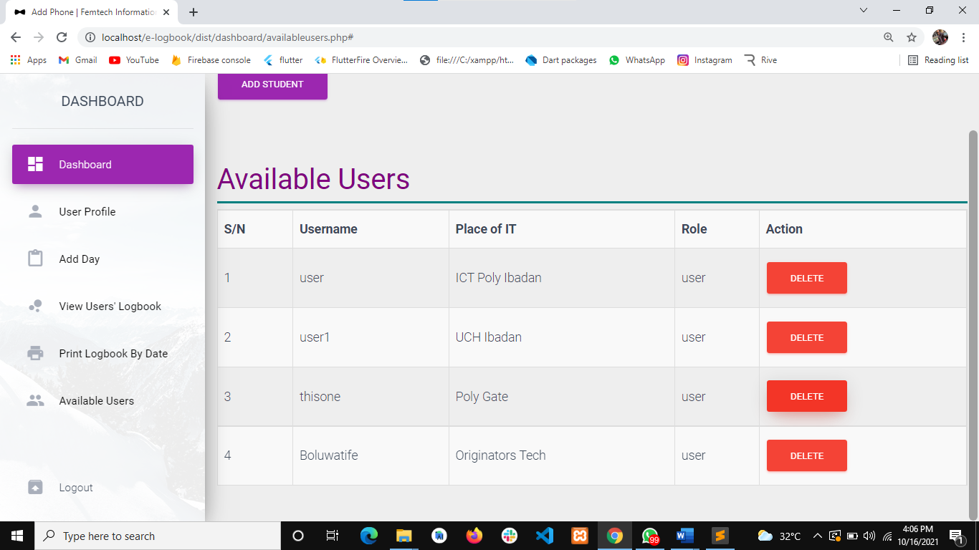

**Fig. 4.1 Users List**

2. 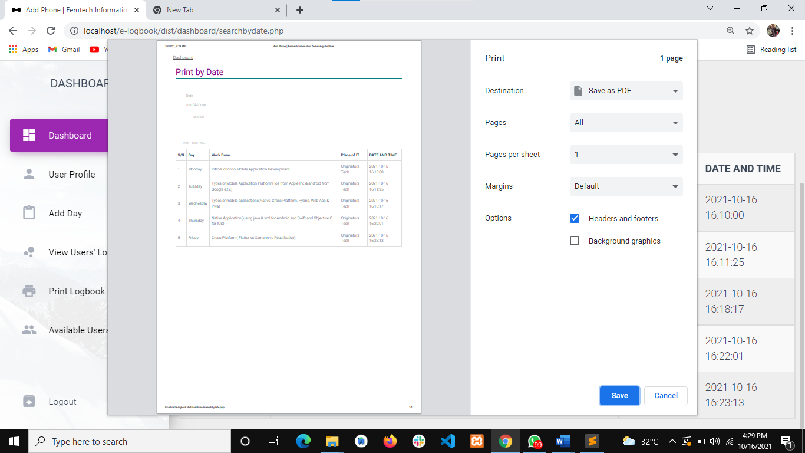

**Fig. 4.2 Logbook Printed by date**

**3.**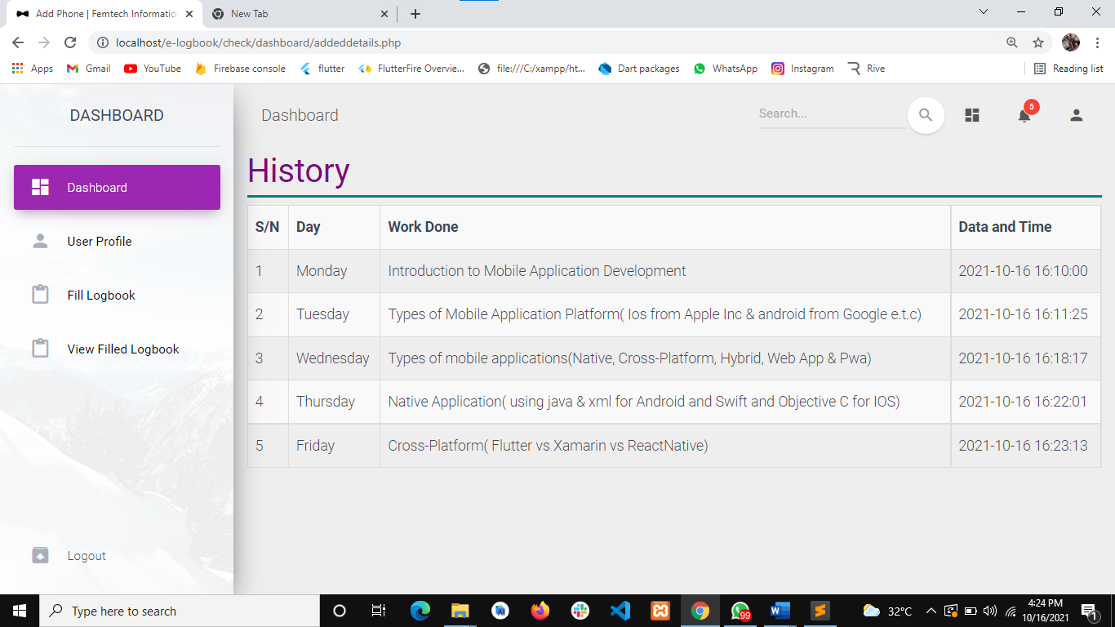

**Fig. 4.3 User Filled Logbook**

**c) Files used to produce reports**

* availabeusers.php
* searchbydate.php
* addeddetails.php

## 4.2 INPUT DESIGN

These are the data fed into the system for the purpose of manipulation, retrieving, recording and maintenance. The devices needed for input are keyboard and mouse.

**a) List of input items required**

* Username
* Password
* Siwes Center
* Day
* Description of work done

**b) Data capture screen forms for input**

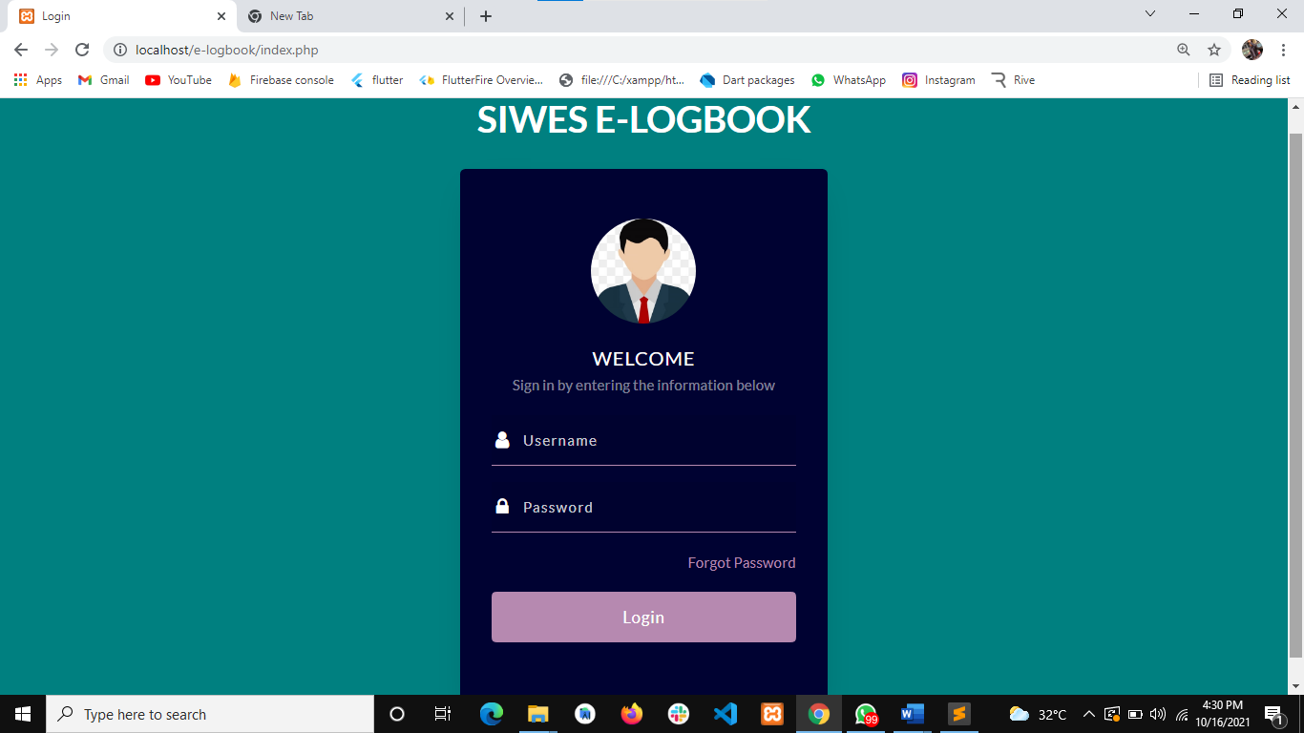

**Fig. 4.4 Login page**

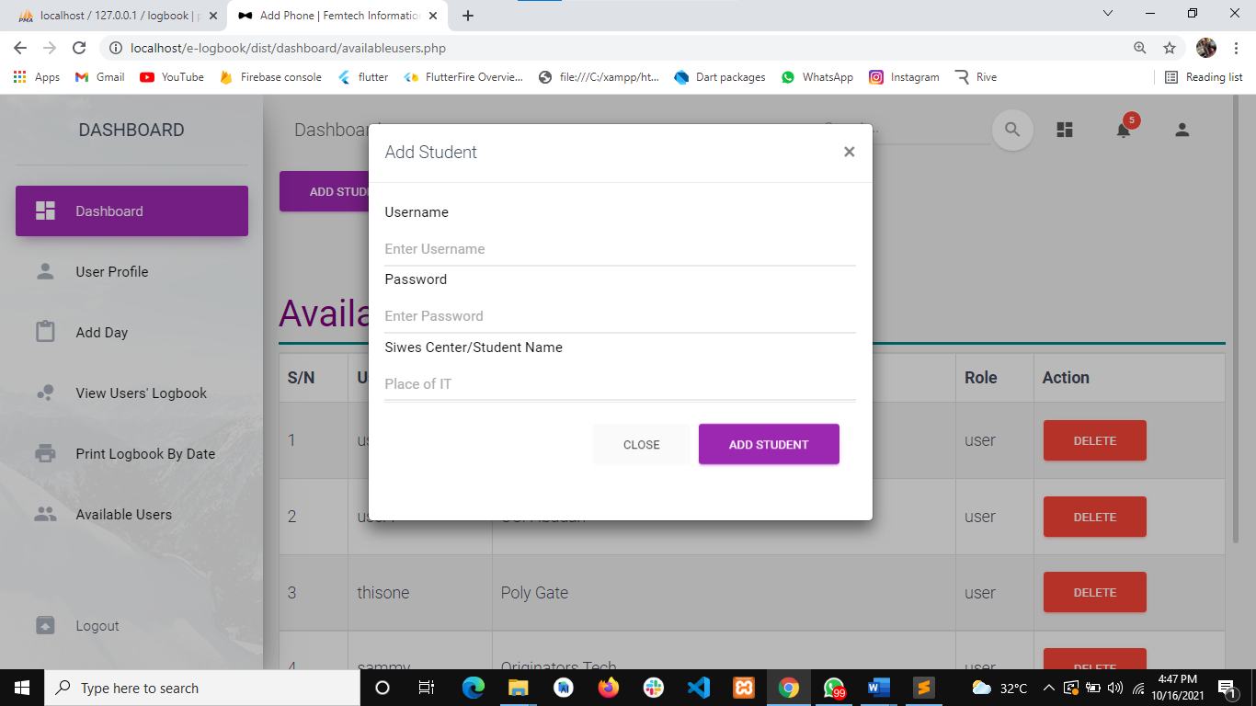

**Fig. 4.5 Add Student page**

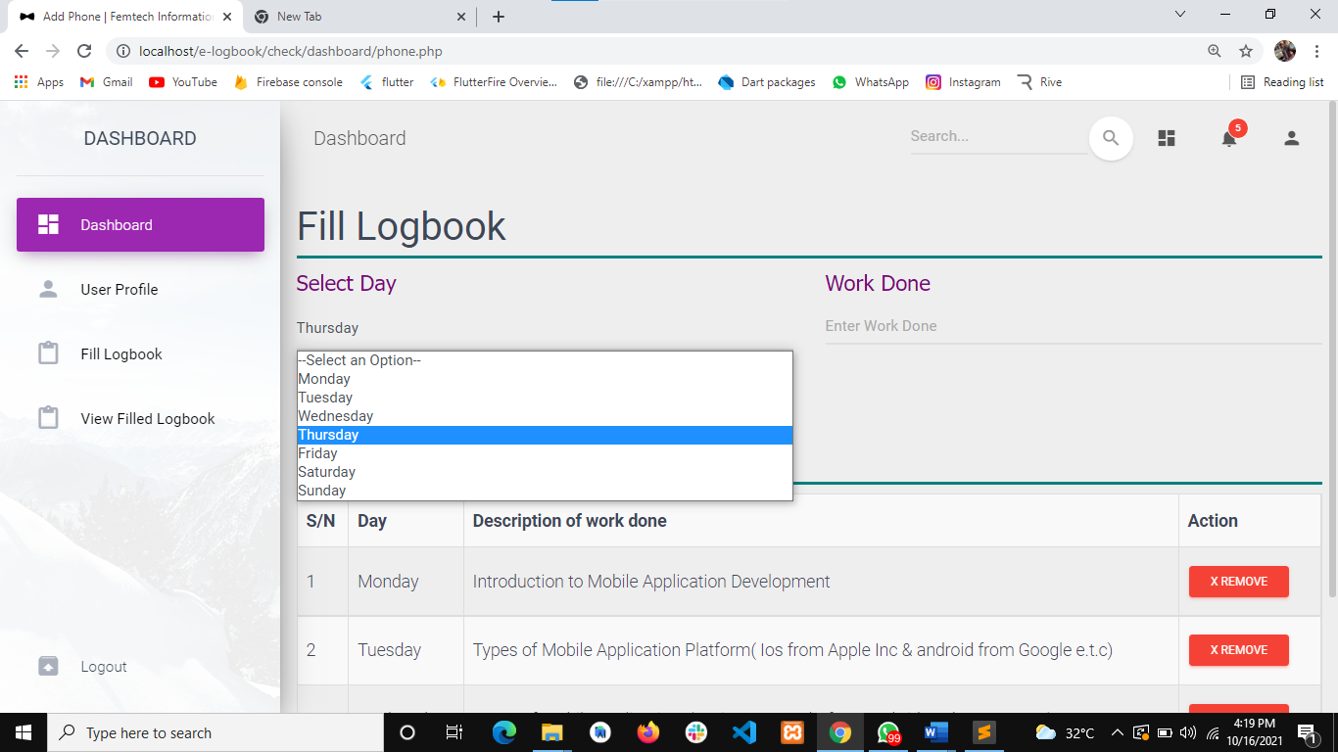

**Fig. 4.6 Fill Logbook page**

**c) Files used to retain inputs**

For the new system, we do not need new files or any other form of storage for saving our inputs. MySQL database is used in saving all incoming data.

## 4.3 PROCESS DESIGN

This system defines the procedures to take towards generating an efficient output. The process design linked every module together to produce a desired output.

**a) List of all programming activities necessary**

Various programming activities are performed to successfully build the new system these activities include:

* The design of the database used.
* Design of the client-side script i.e., JavaScript which enables efficient interaction between the user and the GUI application of the new system.
* HTML coding, this is used in preparing the presentation part of the new system; it helps us to design the pretty look of the website to be created.

PHP coding, which constitute the main and business logic of the new system. All the processes of the system are coded in this area of programming

**b) Program modules to be developed**

Modules are developed individually to perform one function or the other, and they are linked together to work as single system called “Main Program". The major modules developed in this research are:

* Login module
* Admin module
* Student module
* Logbook module.

**c) Virtual Table of Content (VTOC)**

Main Menu

Main Menu

Exit

Login

Fill Logbook/ View Logbook

Register new user/Login

**Fig. 4.7 VTOC**

## 4.4 STORAGE DESIGN

**a) Description of Database Used**

A database is a collection of interrelated data stored with a minimum of redundancy to serve many applications. Database is used to group data into a number of tables and minimizes the artificiality embedded in using separate files.

* MySQL Database: This is an open-source relational database management system (RDBMS). Its name is a combination of "My", the name of the co-founder Michael Widenius's daughter and "SQL", the abbreviation for Structured Query Language. MySQL is free and open-source software under the terms of the GNU General Public License, and is also available under a variety of proprietary licenses.

**b) Description of Files Used**

* Content Provider: Provides all the content needed in the project.
* Contrast: It gets the entire column in the project.
* Data Source: It deals with the update and closing of the database.
* DBOpenHelper: It holds all the data entries in the project.

**c) Record Structure of All Files Used**

**Database name: logbook**

**Table name: phonedetails**

**Input device: Keyboard, mouse**

**Output device: VDU, printer**

**Storage device: Hard disk**

This aspect of the project deals with the skeletal framework of the database. Every file is structured in a format that it can accept extra data as input and be able to print out any additional information.

|  |  |  |
| --- | --- | --- |
| **ATTRIBUTE** | **DATA TYPE** | **LENGTH** |
| Id | integer | 11 |
| Day | Varchar | 255 |
| time_start | Time |  |
| work done | varchar | 255 |
| Branch | Varchar | 255 |
| time_end | Time |  |

Table 4.1. A table showing details of filled Logbook

**Database name: logbook**

**Table name: users**

**Input device: Keyboard, mouse**

**Output device: VDU, printer**

**Storage device: Hard Disk**

|  |  |  |
| --- | --- | --- |
| **ATTRIBUTE** | **DATA TYPE** | **LENGTH** |
| Id | integer | 11 |
| Username | Varchar | 255 |
| Password | Varchar | 255 |
| Siwes Center | Varchar | 255 |
| Role | Varchar | 255 |

Table 4.2. A table showing details of Users

## 4.5 DESIGN SUMMARY

**a) System Flowchart**

Enter login details

Verify username & password on the database

No

Does credentials match?

Yes

Display error message

1. Dashboard
2. Fill Logbook
3. View Filled Logbook

SELECT OPTION

IF OPTION A

Yes

SEND NOTICE

IF OPTION B

No

Yes

VIEW NOTICE

Yes

No

IF OPTION C

PROFILE

No

**b) HIERARCHICAL INPUT PROCESSING OUTPUT (HIPO) CHART**

CREATE SUBADMIN

Enter Fullname, email, phoneno, username, password.

**INPUT PROCESS OUTPUT**

Add Student/Login

SUBMIT

Display Filled Logbook

CREATE

UPDATE

READ

Display Available users

**Fig. 4.9 HIPO chart**

# CHAPTER FIVE

## SYSTEM DEVELOPMENT AND IMPLEMENTATION

## 5.1 PROGRAM DEVELOPMENT ACTIVITY

**a) Programming Language Used:** The programming language used in developing the software is the web language which includes HTML, CSS, JS and PHP. Web language is a concurrent, function-based, content management language.

**(b) Environment Used in Development:** The application was built using a text editor (Bracket) and XAMPP server. XAMPP is a free and open-source cross-platform web server solution stack package developed by Apache Friends consisting mainly of the Apache HTTP Server, MariaDB database, and interpreters for scripts written in the PHP and Perl programming languages.

**c) Source Code:** The source code of this project has been attached to the appendix of this report.

## 5.2 PROGRAM TESTING

During program testing each module of the program were tested to determine the reliability of the system.

**a) Coding Problems Encountered**

As at the time of developing this project, a lot of errors was encountered. They are categorized as follows:

* **Syntax error:** Syntax error is an error in the coding syntax of a language, usually when reserved keywords of the programming language are not spelt correctly. Bracket applies syntax coloring to keywords. Majorly, keywords are highlighted in blue.
* **Too many fields error:**This happens when compiling a PHP code.
* **Path error:** This happens when there is a mistake in the referencing or addressing of an object, file, image etc.

**b) Use of Sample Data**

The various data used for sampling are for easy imputing of activity record, they are used for effective generation of the various reports.

## 5.3 SYSTEM IMPLEMENTATION

System implementation is an important phase in system development cycle. It encompasses all the post-sale processes involved in something operating properly in its environment, including analyzing requirements, installation, [configuration](https://whatis.techtarget.com/definition/configuration), customization, running, testing, systems integrations, user training and making necessary changes. The purpose of system implementation is making the new system available to a prepared set of users and positioning on-going support and maintenance of the system within the performing organization.

**a) System Requirements**

System requirements are the configuration that a system must have in order for a hardware or software application to run smoothly and efficiently. Failure to meet these requirements can result in installation problems or performance problems. When a system starts functioning, it is necessary to monitor its operation to ensure that the user requirements are met. The new system has to be examined from time to time to ensure that it works as expected.

**b) Tasks Prior to Implementation**

**(i) Hardware/Software acquisition**

For easy running of the application on any user’s device, the following are necessary:

* 1280 x 800 maximum screen resolutions.
* 1GB RAM minimum.
* XAMPP or WAMP server.

**(ii) Program installation**

The application is web-based and can be navigated through a URL link.

**c) Staff Training**

This is the process of putting the users through on how to use the application. The new system will be very easy to use and requires no technical training since user do not need much stress than to, login to the system, fill his/her logbook and view the filled logbook, while the administrator monitor the usage of the system.

**d) Changing Over**

This is the process of changing from one system to another especially from the existing manual system to the automated system. There are four different methods of changing from existing system to new system, namely;

1. **Direct change over:** This is a situation in which the system in use is discarded and replaced by a new system. This system is risky and not advisable.
2. **Parallel change over:** This is a situation where the old and new system are being used concurrently; the old system is then discontinued immediately the new system meets all the requirements.
3. **Pilot change over:** The new system is implemented in a specific area of the organization; it is brought into another area of organization immediately it is successful in the first area.
4. **Phased change over:** in here, a new system is tried in a specific area of the organization and if it successful, it will be taken to other areas in the organization.

We recommend that the proposed system uses the parallel change over, because both the old and new system can be used together.

# CHAPTER SIX

## SYSTEM DOCUMENTATION

## 6.1 FUNCTION OF PROGRAM MODULES

Program module is the breakdown of the large program. Each of these modules performs a specific function in the entire program. This module includes Login module, Admin module and Student module, Logbook module.

**Login Module: -** In this module this, users are to input their login details in other to get access to their Dashboard be it the admin or the student.

**Admin Module: -** This is the module that handles the management of the entire system, viewing list of students, register user, view filled logbook, print logbook by date, and also edit and delete them.

**Student Module: -** This module handles the student dashboard, getting access to this dashboard students would be able to fill their logbooks and also view filled logbooks, after filling the logbooks students, have the privileges to submit logbook filled, so as to get to the admin board.

**Logbook Module:** - This is a module in the admin board and the student board, as for the admin he/she is just entitled to view filled logbook submitted by students and also print logbook by date, but on the student logbook part the logbook module only gives student access to fill their logbook in respect to the day and description of work done and also view filled logbook.

## 6.2 USER MANUAL

The system is a very easy package even though the user may not be too good in computer operation. To use this new system, follow these instructions:

**STEP 1** – To run this program, you need a server (XAMPP SERVER) installed on the machine.

**STEP 2** - Copy the project folder to the xampp/htdocs directory on the server.

**STEP 3 -** Run the XAMPP server and make sure you start Apache and MySQL.

**STEP 4** - Open any of your favourite browser and type “localhost/phpmyadmin” to the address bar and hit enter button.

**STEP 5** - Create a new database name ‘logbook’ same name as the database file (logbook.sql) you find the project folder

**STEP 6** - Import the database file.

**STEP 7** - Open another tab on your browser and type “localhost/e-logbook” to the address bar and hit enter button.

**STEP 8** -This will display the index page of the app, then you can start exploring the app from there.

# CHAPTER SEVEN

## SUMMARY, CONCLUSION AND RECOMMENDATION

## 7.1 SUMMARY

This research work focuses on designing of an electronic logbook management system. The system is designed to give students and lecturers easy, fast and reliable means of getting access to logbook without going through the stress of manual paper work. This study was based on the crucial causes and lapses found in the manual system of logbook processes. In course of this study, the Rapid application Development Methodology (RAD) was used. This is to help develop a reliable system with an easy interaction between the user and the system.

## 7.2 CONCLUSION

Electronic Logbook management system was carefully designed and implemented in this research work proved to be efficient and cost-effective. Quite a number of students in both public and private higher institutions currently travel abroad to undertake the SIWES program. This is actually a very good development both for the country and for the students. However, monitoring such students has always been a very tedious task. The newly developed SIWES portal is a timely and adequate solution to this problem and host of other administrative based challenges that have bedeviled the SIWES program over the years. For the next phase of this work, the portal will be deployed and an extensive usability evaluation will be carried out. This will help us to undertake a comparative evaluation of the existing manual approach and the electronic approach to SIWES management using the portal. There is no doubt that a comprehensive electronic logbook management System will enhance the standard of activities involve in SIWES. Literarily speaking, the future is in our hands. While accepting that there are problems with manual management of logbook, it is equally true to say that the organizations must adopt online logbook management system to overcome them. Electronic Logbook management system is a process involving many stakeholders who are expected to perform their expected functions at the right time. These stakeholders are the Admin I.e coordinators of the system, Students etc. The stake is certainly not an easy one, but with proper focus and hard work Electronic Logbook management system is achieved.

## 7.3 RECOMMENDATIONS

Siwes Electronic Logbook management system can be developed further to include, Short Messaging Service (SMS) where by members cellphone numbers has to be stored into the system database. Through small developed stub the system can send notice to users directly to their phone number whenever they are expecting their supervisor’s visit.

1. SIWES portal should be implemented in all tertiary institution.

2. Industry based personal should be properly trained on the use of ICT devices to facilitate

communication with institution based personal.

3. Institution should ensure that their personnel and student are knowledgeable in the use of ICT.

# REFERENCES

1. Ahmed, K., & Keedwell, E. (2017). "A Hidden Markov Model Approach to the Problem of Heuristic Selection in Hyper Heuristics with a Case Study in High Siwes logbook Problems," Massachusetts Institute of Technology, 2017.

2. Olabiyi, Okarfor, & Peter (2012) identify the following as challenges/barriers to effectiveness of industrial training in Nigeria

3. Effah, Bomphong, Adu, Anokye & Asamoah (2014); Gault, Redington and Schlager (2000) also identify barriers such as difficulty in getting placement, poor supervision from industry-based supervisors.

4. Burke & Carter (1998). Practice and Theory of Automated Logbook: Selected Papers from the 2nd International Conference. Lecture Notes in Computer Science, 14 (08), 115 129.

5. Sinnasammy & Nasir (n.d.) unsynchronized training schedules between schools and industry, and varying library systems are barriers/challenges to industrial training of LIS students in Malaysia.

6. Burke, E. K., Hyde, M., Kendall, G., Ochoa, G., Ozcan, E., & Woodward, J. (2009). Exploring hyperheuristic methodologies with genetic programming. In C. Mumford and L. Jain, editors, Collaborative Computational Intelligence. Springer.

7. Nwalo & Oyedum (2011) in their study evaluated the information literacy skills of undergraduate LIS students and found it to be generally poor.

8. Chan, H. W. (1997). "Siwes Using Genetic Search." 2thInternational Conference on the Practice and Theory of Automated logbook, PATAT’97.

9. Costa, D. (1994). "A tabu search algorithm for inputing details." European Journal of Operational Research, 76(1), 98-110

10. Datta, D., Deb K., & Fonseca, C.M. (2006). Multi-objective evolutionary algorithm for university class logbook problem, In Evolutionary Scheduling, Springer-Verlag Press.

11. De Gans O.B. (1981). "A computer system for tertiary in the Netherlands". European Journal of Operations Research,7, 175-182.

12. Deris, S. B., Omatu, S., Ohta, H., & Samat, B. D. (1997)."University documentation by constraint-based reasoning: A case study" Journal of the Operational Research Society, 48(12), 2-4

13. Anunobi & Udem (2015) in their study among postgraduate students of LIS found that the students possessed moderate level of information literacy skills. Esraa, A., & Ghada, E., K. (2016).

14. In India, Barush & Hangsing (2012) assessed the relevance of the rising job market for LIS professionals versus the competencies needed and concluded that there was an ever-widening gap between competencies required on the job market and the course structure.

15. Fang, H. L. (1994). "Genetic Algorithms in logbooks Problems." PhD Thesis, University of Edinburgh.

16. Fernandes, C. (2002). "Infected Genes Evolutionary Algorithm for logbooks managing." SIWES national Conference.

17. Gianoglio, P. (1990)."Application of neural networks to logbook filling." Presented at the 3rd International Workshop on Neural Network and their Applications, Nimes, France.

18. Glover, F. (1986). “Future Paths for Integer Programming and Links to Artificial Intelligence,” Computers and Operations Research, Vol. 13, pp. 533-549.

19. Gotlieb, C. (1962). "The construction of class-teacher time tables. "Proceedings of IFIP Congress, North-Holland Pub. Co., Amsterdam, 73-77.

20. Gröbner, M., & Wilke, P. (2002). "A General View on logbook Problems." 4thInternational Conference on the Practice and Theory of Automated Timetabling -PATAT’02.

21. Hamed, B., Jaber, K. & Amin, H. (2019). "Generating an optimal electronic logbook for multi-departments common students using hybrid fuzzy and clustering algorithms," Methodologies and Application, vol. 23, p. 4735–4747.

22. Iosif, K., Ioannis, T. & Grigorios, B. (2015). "A Comparative Study of Modern Heuristics on the School," Algorithms, vol. 8, no. 3, pp. 723-742.

23. Kheiri, A., & Ed, K. (2017). "A Hidden Markov Model Approach to the Problem of Heuristic Selection in Hyper Heuristics with a Case Study in High School records Problems," Evolutionary Computation, vol. 25, no. 3, pp. 473501.

24. Kirkpatrick, S., Gelatt Jr., C. D. & Vecchi, M. P. (1983). Optimization by Simulated Annealing. Science, 220, 671-680.

25. Lajos, G. (1995). "Complete university modular timetabling using constraint logic programming." Presented at the Ist International Conference on thePractice and Theory of Automated Timetabling, Scotland, UK.

26. Lawrie, N.L. (1969). "An integer programming model of a school timetabling problem." The Computer Journal, 12, 307-316

27. Looi, C. (1992). "Neural network methods in combinatorial optimization" Journalof Computers and Operations Research, 19(3/4), 191-208.

28. Mahmoud, S., Mahmoud, N., & Mohammad, M., M. (2020). "Optimal Localization of Shopping Centers Using Metaheuristic Genetic Algorithm," Journal of Optimization in Industrial Engineering, vol. 13, no. 1, pp. 167 176.

29. Nelishia, P., & Ender, O. (2019). "Automated generation of constructive ordering heuristics for educational timetabling," Annals of Operations Research, vol. 275, no. 1, p. 181–208.

30. Paechter B., Cumming A., Luchian H., & Petriuc M. (1994)." Two solutions to the general timetable problem using evolutionary methods." Presented at the3rd World Conference on Evolutionary Computing. Florida, USA.

31. Piola, R. (1994). "Evolutionary solutions to a highly constrained combinatorial problem." In Proceedings of IEEE Conference on Evolutionary Computation (First World Congress on Computational Intelligence), Orlando, Florida, 1, 446-450

32. Rakesh, B., Gupta & Pallav, I., (2014). "A new hybrid algorithm for university course logbook problem using events based on groupings of students," Computers & Industrial Engineering, vol. 78, pp. 12-25.

33. Robertus J. W. (2002). Siwes logbook construction -Algorithm and Complexity,1st ed. Netherlands: University of Eindhoven Press.

34. `Schaerf A. (1999). A survey of automated timetabling. Artificial Intelligence Review, 13 (2), 87-127.

35. Srinivasan D., Seow T.H., & Xu J.X., (2002). "Automated logbook generationusing multiple context reasoning for university modules." In Proceedingsof IEEE International Conference on Evolutionary Computation (CEC'02), 1751-1756.

36. Suliadi, S., Ahmad, I., Maselan, A., & Siti, R. (2018). "A Heuristics Approach for Classroom Scheduling Using Genetic Algorithm Technique," Journal of Physics: Conference Series, vol. 995.

37. Suresh, L., Ajinkya, K., Akash, T., Manasi, M., & Yogesh, C. (2014). "Genetic Algorithm: Paradigm Shift over a Traditional Approach of Logbook inputing," in Proceedings of the 3rd International Conference on Frontiers of Intelligent Computing: Theory and Applications (FICTA) 2014, Switzerland, 2014.

38. Tan, L., Joe, O., Yu-Beng, L. & Jetol, B. (2018). "Implementation of Constraint Programming and Simulated Annealing for keeping records Problem," Computational Science and Technology, vol. 481, pp. 175 184.Tripathy A. (1984). "Siwes logbook - A case in large binary integer linear programming." Management Science, 30(12), 1473-1489.

# APPENDIXES

## APPENDIX A

## SYSTEM FLOWCHART

Enter login details

Verify username & password on the database

No

Does credentials match?

Yes

Display error message

1. Dashboard
2. Fill Logbook
3. View Filled Logbook

SELECT OPTION

IF OPTION A

Yes

SEND NOTICE

IF OPTION B

No

Yes

VIEW NOTICE

Yes

No

IF OPTION C

PROFILE

No

## APPENDIX B

## SOURCE CODE

<?php

session_start();

ob_start();

include('check/dashboard/includes/db.php');

if (isset($_POST['login'])) {

$username = $_POST['username'];

$password = $_POST['password'];

// $role = 'admin';

$pasLen = strlen($password);

if (empty($username) or empty($password)) {

$msg = "Both fields are compulsory fields";

}elseif ($pasLen < 6) {

$msg = "Password length is too weak";

}

else {

$query = "SELECT * FROM users WHERE username='$username' and password='$password'";

$result = mysqli_query($connection, $query);

$num_rows = mysqli_num_rows($result);

if ($num_rows == 1) {

$arr = mysqli_fetch_array($result);

$username_db = $arr['username'];

$password_db = $arr['password'];

$role_db = $arr['role'];

$branch = $arr['branch'];

if ($role_db == 'admin') {

$_SESSION['username'] = $username_db;

$_SESSION['branch'] = $branch;

// $_SESSION['role'] = $role_db;

header("Location: dist/dashboard");

}else{

$_SESSION['username'] = $username_db;

$_SESSION['branch'] = $branch;

header("Location: check/dashboard");

}

}else{

$msg = "Invalid Login Details";

}

}

}

?>

<!doctype html>

<html lang="en">

<head>

<title>Login</title>

<meta charset="utf-8">

<meta name="viewport" content="width=device-width, initial-scale=1, shrink-to-fit=no">

<link href="https://fonts.googleapis.com/css?family=Lato:300,400,700&display=swap" rel="stylesheet">

<link rel="stylesheet" href="https://stackpath.bootstrapcdn.com/font-awesome/4.7.0/css/font-awesome.min.css">

<link rel="stylesheet" href="css/style.css">

<!-- <link rel="stylesheet" href="https://maxcdn.bootstrapcdn.com/bootstrap/4.0.0/css/bootstrap.min.css" integrity="sha384-Gn5384xqQ1aoWXA+058RXPxPg6fy4IWvTNh0E263XmFcJlSAwiGgFAW/dAiS6JXm" crossorigin="anonymous"> -->

</head>

<body style="background-color: teal;">

<div style="margin-top: 10px;">

<center>

<p style="color: white; font-weight: bolder; font-size: 35px;">

SIWES E-LOGBOOK

</p>

</center>

</div>

<section class="ftco-sectionv">

<div class="container">

<!-- <div class="row justify-content-center">

<div class="col-md-6 text-center mb-5">

<h2 class="heading-section">Login</h2>

</div>

</div> -->

<div class="row justify-content-center">

<div class="col-md-6 col-lg-4">

<div class="login-wrap py-5">

<div class="img d-flex align-items-center justify-content-center" style="background-image: url(images/user.jpg);"></div>

<?php echo "<div style=' text-align: center;'><span style='color: red; font-weight: bolder;'>" .@$msg. "</span></div>"; ?>

<!-- <div class="card" style="text-align: center; padding: 10px;"> -->

<h3 class="text-center mb-0">Welcome</h3>

<p class="text-center">Sign in by entering the information below</p>

<form action="index.php" class="login-form" method="post">

<div class="form-group">

<div class="icon d-flex align-items-center justify-content-center"><span class="fa fa-user"></span></div>

<input type="text" name="username" class="form-control" placeholder="Username" required>

</div>

<div class="form-group">

<div class="icon d-flex align-items-center justify-content-center"><span class="fa fa-lock"></span></div>

<input type="password" name="password" class="form-control" placeholder="Password" required>

</div>

<div class="form-group d-md-flex">

<div class="w-100 text-md-right">

<a href="#">Forgot Password</a>

</div>

</div>

<div class="form-group">

<button type="submit" name="login" class="btn form-control btn-primary rounded submit px-3">Login</button>

</div>

</form>

<div class="w-100 text-center mt-4 text">

<!-- <p class="mb-0">Don't have an account?</p> -->

<!-- <a href="#">Sign Up</a> -->

</div>

</div>

</div>

<!-- </div> -->

</div>

</div>

</section>

<script src="js/jquery.min.js"></script>

<script src="js/popper.js"></script>

<script src="js/bootstrap.min.js"></script>

<script src="js/main.js"></script>

</body>

</html>

## APPENDIX C

## SAMPLE INPUT



**Fig. 4.4 Login page**



**Fig. 4.5 Add Student page**



**Fig. 4.6 Fill Logbook page**

## APPENDIX D

## SAMPLE OUTPUT



**Fig. 4.1 Users List**

2. 

**Fig. 4.2 Logbook Printed by date**

**3.**

**Fig. 4.3 User Filled Logbook**

_____________________________________________________________________________________________

The Centre was established in compliance with the Federal Government's initiative through NBT Ethat all tertiary institutions in Nigeria must establish Entrepreneurship Development Centres (EDC) to solve graduates unemployment crises by ensuring that they acquire functional entrepreneurial skills, desirable work habit in addition to their formal education which will enable them to be self-reliant, self-employed and productive members of the society. To this end, Vocational Skills and Entrepreneurship Study Centre (VSESC) was resuscitated by the school management in June2008 after the extinction of the old Vocational Skills Improvement Unit (VSIU) to serve as community service and revenue generating outfit. This is a double barrel conception viz: skill acquisition programme and entrepreneurship development of graduates of this institution. In fact, Vocational Skills and Entrepreneurship Study Centre (VSESC) is to ensure that all graduates of the Polytechnic, Ibadan are practically sound in at least one vocational/entrepreneurial skill before graduation so that they can be self-reliant, self-employed and employer of labour rather than job seekers. The blue print establishing the Centre has the following vision, mission, specific objective and basic policies: